
GCS Sidekick (GCSS)

Documentation
May 25, 2011

Project Lead: David Gitz, ICARUS Lead Engineer
Assigned Employees: None.

This is a working document to describe the GCSS.

Purpose:
The GCSS will be a product that interfaces to a User supplied laptop that will provide video and communications to the ICARUS Vehicle in a small and cost-effective package.

Description:
The GCSS will consist of the following sub-systems:
- Power
- Communications
- Video

The Power Sub-System will provide all power required to the Communications and Video Sub-Systems.

The Communication Sub-System will provide communications to the GCS-Interface software that will be run on a user supplied laptop. This will communicate directly with the ICARUS Vehicle through an XBee radio. While offering smaller range than the GCS, due to the limited height of the GCSS it will provide the same basic functionality of the GCS.

The Vide Sub-System will receive analog Video transmitted from a camera mounted on the Vehicle, convert it to a USB format (to allow for compatibility with common laptop’s) and will display in the GCSI.

As the maximum current draw (during transmission) of the currently selected RF transmitter is a large percentage of the available power supply of 1 USB port, connection through a USB Hub is not possible and instead the GCSS will have at least 2 (RF + Video) USB Connections.

Functional Diagram
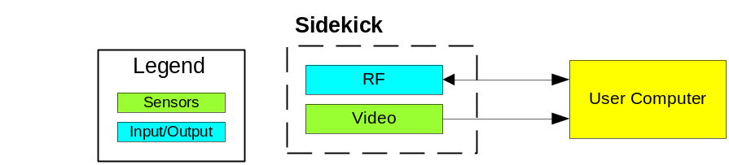

3D Design
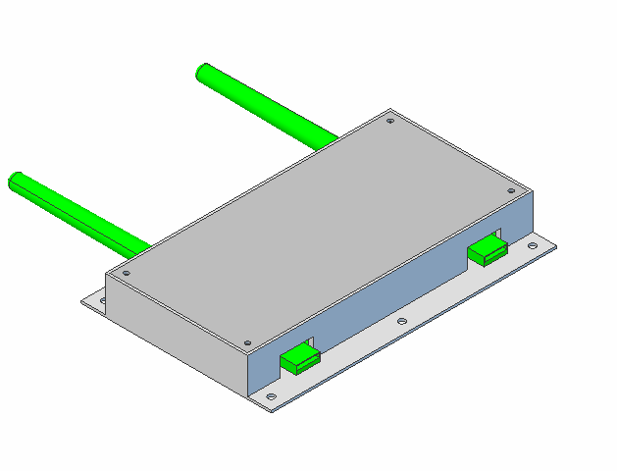

Requirements

Requirements

Requirement | Target | Goal
Mounting | Velcro
PCB | None
Production Cost | $150 | $125
Prototype Cost | $250 | $200
Size (minus Antennas, Cables) | 6”x4”x1.5” | 3”x3”x.75”
Weight | >2 lbs | < 1 lb

Requirements Description

Mounting
Sidekick should be able to mount directly onto the back of a User’s laptop.

PCB
In an effort to keep costs/development time down, all COTS items will be used and no PCB will be required to be developed.

Production Cost
Cost should be minimal to not significantly affect the production cost of the Simple Option.

Prototype Cost
Cost should be minimal as projected component count is few and there is minimal engineering required.

Size
Due to the usage of all COTS items, the size of the Sidekick may not be as small as desired but efforts to reduce the size should be made.

Weight
The weight of the Sidekick should be minimal as it will be mounted directly on the back of a User’s laptop.

Authorizations

Timeframe
Start Work:
Initial Development Complete:
Development Debugging Complete:
Prototype Complete:

